C6H12O6-MATE Hypoglycemic System

Kelton Chesshire - Software Design

Abhimanyu Singh - Microcontroller Design

Holden Haile - Power Supply Design

**Concept of Operations**

Concept of Operations

for

C6H12O6-MATE Hypoglycemic System

Team <32>

Approved by:

**Kelton Chesshire 4/19/2022**

Project Leader Date

**Professor Kalafatis 4/20/2022**

Prof. Kalafatis Date

**Sambandh Dhal 4/20/2022**

T/A Date

**Table of Contents**

[**Table of Contents III**](https://docs.google.com/document/d/1HfkcKBzjIcywpFx4A5mByQcZ8NTnFTCiabZJldOih7U/edit#heading=h.30j0zll)

[**1.** **Executive Summary 1**](https://docs.google.com/document/d/1l9vDX7_9_HhvjjICsjhHEvT9ROSyDO_m/edit#heading=h.1t3h5sf)

[**2.** **Introduction 2**](https://docs.google.com/document/d/1HfkcKBzjIcywpFx4A5mByQcZ8NTnFTCiabZJldOih7U/edit#heading=h.4d34og8)

[2.1. Background 2](https://docs.google.com/document/d/1HfkcKBzjIcywpFx4A5mByQcZ8NTnFTCiabZJldOih7U/edit#heading=h.2s8eyo1)

[2.2. Overview 2](https://docs.google.com/document/d/1HfkcKBzjIcywpFx4A5mByQcZ8NTnFTCiabZJldOih7U/edit#heading=h.17dp8vu)

[2.2.](https://docs.google.com/document/d/1HfkcKBzjIcywpFx4A5mByQcZ8NTnFTCiabZJldOih7U/edit#heading=h.17dp8vu) Model Sketch

[**3.** **Operating Concept 3**](https://docs.google.com/document/d/1HfkcKBzjIcywpFx4A5mByQcZ8NTnFTCiabZJldOih7U/edit#heading=h.lnxbz9)

[3.1. Scope 3](https://docs.google.com/document/d/1HfkcKBzjIcywpFx4A5mByQcZ8NTnFTCiabZJldOih7U/edit#heading=h.35nkun2)

[3.2. Operational Description and Constraints 3](https://docs.google.com/document/d/1HfkcKBzjIcywpFx4A5mByQcZ8NTnFTCiabZJldOih7U/edit#heading=h.1ksv4uv)

[3.3. System Description 3](https://docs.google.com/document/d/1HfkcKBzjIcywpFx4A5mByQcZ8NTnFTCiabZJldOih7U/edit#heading=h.44sinio)

[3.4. Modes of Operations 3](https://docs.google.com/document/d/1HfkcKBzjIcywpFx4A5mByQcZ8NTnFTCiabZJldOih7U/edit#heading=h.2jxsxqh)

[3.5. Users 3](https://docs.google.com/document/d/1HfkcKBzjIcywpFx4A5mByQcZ8NTnFTCiabZJldOih7U/edit#heading=h.z337ya)

[3.6. Support 3](https://docs.google.com/document/d/1HfkcKBzjIcywpFx4A5mByQcZ8NTnFTCiabZJldOih7U/edit#heading=h.3j2qqm3)

[**4.** **Scenario(s) 4**](https://docs.google.com/document/d/1HfkcKBzjIcywpFx4A5mByQcZ8NTnFTCiabZJldOih7U/edit#heading=h.1y810tw)

[4.1. Regular Operation](https://docs.google.com/document/d/1HfkcKBzjIcywpFx4A5mByQcZ8NTnFTCiabZJldOih7U/edit#heading=h.4i7ojhp) 4

[4](https://docs.google.com/document/d/1HfkcKBzjIcywpFx4A5mByQcZ8NTnFTCiabZJldOih7U/edit#heading=h.4i7ojhp).2. [Operation without application](https://docs.google.com/document/d/1HfkcKBzjIcywpFx4A5mByQcZ8NTnFTCiabZJldOih7U/edit#heading=h.nn4yqujxp13d) 4

4.3 [Operation with Glucose Meters](https://docs.google.com/document/d/1HfkcKBzjIcywpFx4A5mByQcZ8NTnFTCiabZJldOih7U/edit#heading=h.ajazrbovf28h) 4

[**5.** **Analysis 4**](https://docs.google.com/document/d/1HfkcKBzjIcywpFx4A5mByQcZ8NTnFTCiabZJldOih7U/edit#heading=h.2xcytpi)

[5.1. Summary of Proposed Improvements 4](https://docs.google.com/document/d/1HfkcKBzjIcywpFx4A5mByQcZ8NTnFTCiabZJldOih7U/edit#heading=h.1ci93xb)

[5.2. Disadvantages and Limitations 4](https://docs.google.com/document/d/1HfkcKBzjIcywpFx4A5mByQcZ8NTnFTCiabZJldOih7U/edit#heading=h.3whwml4)

[5.3. Alternatives 4](https://docs.google.com/document/d/1HfkcKBzjIcywpFx4A5mByQcZ8NTnFTCiabZJldOih7U/edit#heading=h.2bn6wsx)

[5.4. Impact 4](https://docs.google.com/document/d/1HfkcKBzjIcywpFx4A5mByQcZ8NTnFTCiabZJldOih7U/edit#heading=h.qsh70q)

# **Executive Summary**

Low Blood sugar or Hypoglycemia is a silent but possibly lethal condition of the body in which the person is starved of sugar, the main nutrient that is used to feed the billions of cells in the human body. This condition leads to symptoms that can severely impact decision-making, as well as several other symptoms that ultimately lead to loss of consciousness if not treated immediately and effectively. There are many ways to track blood sugar, but being able to accurately give the user the amount of sugar they need to restore their blood sugar to normal levels can be tricky and requires experimentation.

Our device shall be a tool for those who suffer from Hypoglycemia in order to take preventative action to dose the user when their blood sugar begins to drop below acceptable conditions. We hope to provide a smooth running and adaptive source of accurate sugar dispensing to our consumers. Accomplishing both a maintenance efficient and emergency equipped system to ease some of the stress that the user must deal with on a day to day basis.

# **Introduction**

Our device has the ability to change the lives of thousands of people all over the world on a daily basis with its revolutionary way of dispensing precise counts of calories in the form of something as simple as skittles and juice. This device shall be a partner to anyone suffering from hypoglycemia, always prepared to give them the dietary advice they need at any point in the day. It shall be learning and evolving with the user as they use it more so that it shall be able to make predictions based on their past patterns. We hope to create a device that shall help ease the pressure of maintaining glucose levels when at any moment the situation can go awry.

## ***Background***

When someone is experiencing low blood sugar their ability to think critically and make decisions is greatly impacted. As far as our research can tell there are many ways for people to track their blood sugar levels as well as their calorie intake. These systems, however, do not aid in the measurement and identification of foods that shall fulfill their needs. This is the main objective of our device. We hope to provide a means of exactly measuring and dispensing calories and nutrients to the consumer so that they can avoid the many steps it would take for them to identify the correct foods while under the influence of low blood sugar. Furthermore, people with low blood sugar need to re-check their blood sugar status shortly after they eat. Our system shall check up on the user shortly after we have dispensed their dosage.

## ***Overview***

The base function of the device shall be to dispense a specific amount of calories to the user based on their dietary needs. Beyond this core functionality, we shall create a system of communication with an app. In addition, we hope to have the capability to track the stock left in the machine at any time to ensure that the user is not left without anything to dispense from the device. The app shall have many capabilities, such as the ability to track past glucose measurements, connect to a CGM(continuous glucose monitor) that someone may already have, and use the stock tracker to automatically order you more stock.

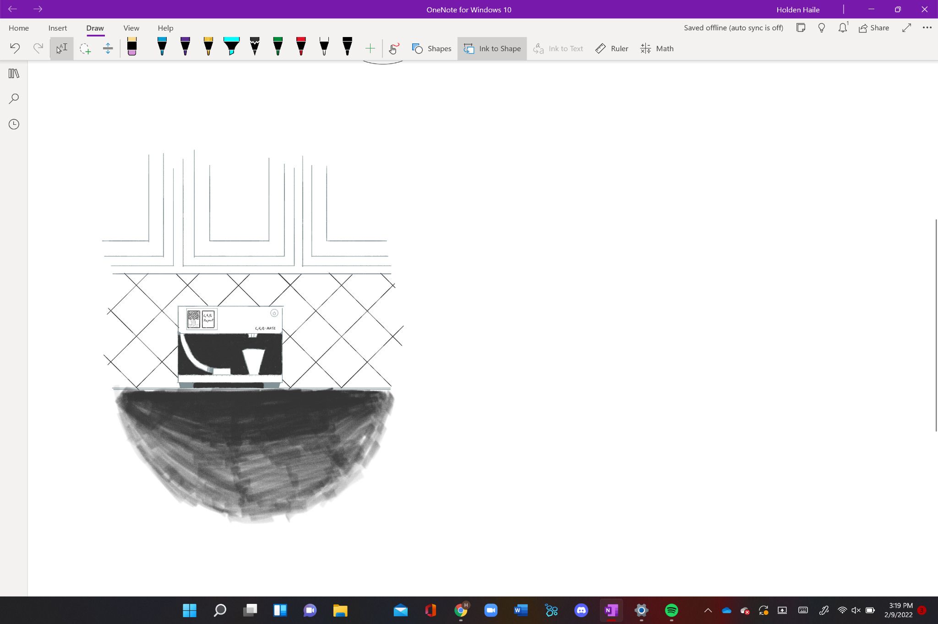

# **Operating Concept**

## ***Scope***

Our project shall require that the team implements everyone’s knowledge of both the software and hardware in order to create a system that meets our criteria of being reliable and accurate for any user who wants to use the system. This shall require trial and error testing in order to meet the standard that we want to deliver to our users. The system shall include a smart dispensing system that accurately alerts the user when to take their suggested dosage, and accurately dispense the correct amount of sugar/carbohydrates to the user. The system shall also include a mobile application that shall provide the user with interactive trends as well as the ability to enter vital information about the user.

## ***Operational Description and Constraints***

Our project shall be used by the consumer through the use of an app. Through the app, they shall be able to record their blood glucose level, connect their CGM (Continuous Glucose Monitor), input their height, weight, and nutritional information, and interact with the dispenser to determine the number of calories they require. They shall also be able to interact directly with the device as it shall have a built-in touch display that shall allow for the user to enter information for immediate dispensing. Constraints for our system include cost, as we will be operating under a limited budget. We are also operating under the assumption that users of this device will have an easy way to measure their glucose levels, whether that’s in the form of a Continuous Glucose Monitor or more traditional glucose monitors.

## ***System Description***

Our system is composed of both the Hypoglycemic center, which is a dispensing system that contains hardware components that work in conjunction with our server and mobile UI that all tie in together to provide our users with a complete system for managing their glucose levels.

* + 1. **Dispensing System**

**Hardware Components:**

* Microprocessor - Controls dispensing as well as wireless connectivity and serial communication with digital display.
* Power Supply - Provides 12V and 5V rails to power the entire system that is supplied from standard 120V AC wall power.
* Digital Touch Display - This will be the user’s way of interacting with the dispenser when they dont have their phone.
* Liquid and Skittle Dispenser - Dispenses appropriate liquid and skittles based on user input.
* Alert system - Will alert the user if they need to take a dose or if their dose was insufficient.
  + 1. **Mobile User Interface and Cloud System**

**Software Components:**

* Mobile Application - The application will handle and store user data, so the user can have access to their glucose and carbohydrate information. The app will deliver notifications from the device to the user remotely, so the user doesn’t have to be directly next to the machine for these alerts. The app will also interface with glucose monitors and other health data through APIs such as Apple’s HealthKit.
* Cloud Server (Firebase & Cloud MQTT) - The servers will be used to host the important backend information required to run the app. Further details are outlined below.
  + Cloud Database - Will track historic vital information for each user that is registered to the service that our system provides. This information will be accessible within the application.
  + Cloud Communication Broker - Will allow the application to interface with the machine through the MQTT Protocol over a WiFi connection, ensuring reliable connectivity and communication between the devices.

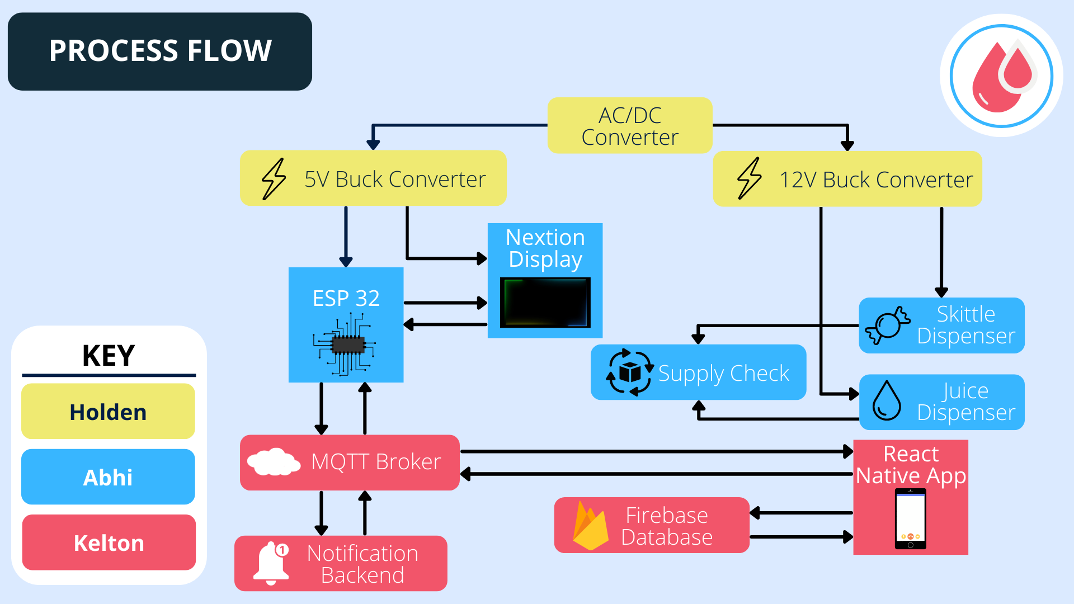

## ***Modes of Operations***

Our device shall operate as both a phone application and a stand-alone system giving the user additional flexibility in their way of connecting to its interface. It shall also operate as a tracker of past doses and blood sugar levels in order to provide another means of informing the user of the subtleties in their condition.

## ***Users***

Our device shall be designed in a user-friendly way that shall allow for people of all ages to easily manipulate its systems. We hope to be able to reach anyone that is suffering from Hypoglycemia no matter how well they understand the technology behind our device. The end product shall allow for someone to make it as complex or simple as they desire. The complexity comes from the implementation of their CGM data and its ability to monitor your blood glucose levels on its own, down to its most simple functions of telling it your levels and returning the correct amount of calories.

## ***Support***

## The device shall most assuredly come with a setup manual as well as all the details on how to refill and maintain the systems of dispensing food to the consumer. There shall also be some information on common fixes necessary in the manual. For the most part, we hope to have a device that is as simple as a Keurig. Mostly just plug it in and have a few steps for preparing the liquid dispersion. The app side shall be self-contained having all of its instructions as well as backups of the instructions for the device itself within its own system. This shall avoid too much information being located in the manual of the device for those who wish to use the device alone without the app.

# **Scenario(s)**

## ***Regular Operation***

The user approaches the device and inputs their current blood sugar reading. The device then dispenses the required amount of Skittles and sugary liquid for the user's blood sugar to reach nominal levels. The device reports the information to the application on the user’s phone via Wifi communication, which keeps track of previous dispensing and reports trending information back to the user. In the event of the device being out of materials to dispense or an error occurs, a warning message will be displayed on the device, and a notification will be displayed on the user’s phone via the app.

## ***Operation without application***

In the event the device cannot connect to the application on the user’s phone, the device will still be able to operate almost all functions. The user will still be able to input their blood sugar reading into the device, which will then dispense the required amount of sugary liquid and/or Skittles to return the user’s glucose levels to a normal state. If an error occurs or the machine is running low on materials, this information will be displayed directly on the screen.

## ***Operation with Glucose Meters***

Through the use of “smart” glucose meters that can connect to the user’s smartphone and health API systems such as Apple’s HealthKit, the application for the device will be able to have a constant reading of the user’s glucose levels. From this, the application can determine when to dispense liquid or Skittles to the user. A notification will display on the user’s phone, recommending a certain amount of liquid or Skittles to be dispensed. If the user so chooses, the application will then connect to the machine and dispense the requested materials.

# **Analysis**

## ***Summary of Proposed Improvements***

## Exact glucose dispensing

## Tracking of blood glucose levels

## Add several fail-safes to the system so that we can handle situations where the patient may be on the verge of unconsciousness

## Allow for the user to connect a CGM for even more interactive capabilities within the system

## Monitor stock levels of skittles and juice and automatically order more when the stock is low

## ***Disadvantages and Limitations***

The User will have to have their own way of measuring actual blood glucose levels, our system does not include any sort of blood sugar meter/tester. This is a disadvantage for a user wanting a complete system, but in the case of developing and testing a glucose meter, we will be delegating vast amounts of time and recourse in order to get a system running, we have decided to go the route of letting the user use the glucose meter that they are most comfortable with.

## ***Alternatives***

Connection with Professional Healthcare that can monitor and dispense appropriate glucose as well as any other medication. This is not so much of an alternative solution as it is a further improvement in our design that is out of our scope as we have not scoped to establish a software tie with hospitals since that can be a security risk for hospitals, and dispensing medication alongside glucose is subject to a greater degree of liability. We also had one change that was made to our design. We considered having the users input their required carbohydrates rather than their current glucose level, thereby eliminating the need for a glucose monitor. But by operating under the assumption that most diabetics carry a glucose monitor of some form on them we can leverage this and have the machine handle accurate carbohydrate dispensing, while also having a way to document their glucose levels directly.

## ***Impact***

The only effect that our device would have is to better the lives of the users. The only trouble that it may run into would be if our procedure to predict the correct amount of calories fails and someone sustains emergency levels of low blood sugar as a result. With this in mind, we hope to have a fail-safe in which they must check in with the app after a certain amount of time. If they fail to do this it shall alert a designated emergency contact. Other than this issue, our system does not infringe on any ethical boundaries or have any effect on the environment besides production emissions and was

C6H12O6-MATE Hypoglycemic System

Kelton Chesshire - Software Design

Abhimanyu Singh - Microcontroller Design

Holden Haile - Power Supply Design

**Functional System Requirements**

Functional System Requirements

for

C6H12O6-MATE Hypoglycemic System

Prepared by:

**Abhi Singh 2/15/2022**

Author Date

Approved by:

**Kelton Chesshire 2/23/2022**

Project Leader Date

**Professor Kalafatis 2/15/2022**

Prof. Kalafatis Date

**Sambandh Dhal 2/23/2022**

T/A Date

**Table of Contents**

[**Table of Contents III**](https://docs.google.com/document/d/1HfkcKBzjIcywpFx4A5mByQcZ8NTnFTCiabZJldOih7U/edit#heading=h.1fob9te)

[**List of Figures IV**](https://docs.google.com/document/d/1HfkcKBzjIcywpFx4A5mByQcZ8NTnFTCiabZJldOih7U/edit#heading=h.2et92p0)

[**1.** **Introduction 1**](https://docs.google.com/document/d/1HfkcKBzjIcywpFx4A5mByQcZ8NTnFTCiabZJldOih7U/edit#heading=h.tyjcwt)

[1.1. Purpose and Scope 1](https://docs.google.com/document/d/1HfkcKBzjIcywpFx4A5mByQcZ8NTnFTCiabZJldOih7U/edit#heading=h.3dy6vkm)

[1.2. Responsibility and Change Authority 1](https://docs.google.com/document/d/1HfkcKBzjIcywpFx4A5mByQcZ8NTnFTCiabZJldOih7U/edit#heading=h.4d34og8)

[**2.** **Applicable and Reference Documents 2**](https://docs.google.com/document/d/1HfkcKBzjIcywpFx4A5mByQcZ8NTnFTCiabZJldOih7U/edit#heading=h.2s8eyo1)

[2.1. Reference Documents 2](https://docs.google.com/document/d/1HfkcKBzjIcywpFx4A5mByQcZ8NTnFTCiabZJldOih7U/edit#heading=h.3rdcrjn)

[**3.** **Requirements 4**](https://docs.google.com/document/d/1HfkcKBzjIcywpFx4A5mByQcZ8NTnFTCiabZJldOih7U/edit#heading=h.35nkun2)

[3.1. System Definition 4](https://docs.google.com/document/d/1HfkcKBzjIcywpFx4A5mByQcZ8NTnFTCiabZJldOih7U/edit#heading=h.1ksv4uv)

[3.2. Characteristics 4](https://docs.google.com/document/d/1HfkcKBzjIcywpFx4A5mByQcZ8NTnFTCiabZJldOih7U/edit#heading=h.2jxsxqh)

[3.2.1. Functional / Performance Requirements 4](https://docs.google.com/document/d/1HfkcKBzjIcywpFx4A5mByQcZ8NTnFTCiabZJldOih7U/edit#heading=h.z337ya)

[3.2.2. Physical Characteristics 5](https://docs.google.com/document/d/1HfkcKBzjIcywpFx4A5mByQcZ8NTnFTCiabZJldOih7U/edit#heading=h.3j2qqm3)

[3.2.3. Electrical Characteristics 6](https://docs.google.com/document/d/1HfkcKBzjIcywpFx4A5mByQcZ8NTnFTCiabZJldOih7U/edit#heading=h.1y810tw)

[3.2.4. Environmental Requirements 8](https://docs.google.com/document/d/1HfkcKBzjIcywpFx4A5mByQcZ8NTnFTCiabZJldOih7U/edit#heading=h.2xcytpi)

[3.2.5. Dispenser Failsafe 9](https://docs.google.com/document/d/1HfkcKBzjIcywpFx4A5mByQcZ8NTnFTCiabZJldOih7U/edit#heading=h.3whwml4)

[**4.** **Support Requirements 10**](https://docs.google.com/document/d/1HfkcKBzjIcywpFx4A5mByQcZ8NTnFTCiabZJldOih7U/edit#heading=h.2bn6wsx)

[**Appendix A Acronyms and Abbreviations 11**](https://docs.google.com/document/d/1HfkcKBzjIcywpFx4A5mByQcZ8NTnFTCiabZJldOih7U/edit#heading=h.qsh70q)

[**Appendix B Definition of Terms 12**](https://docs.google.com/document/d/1HfkcKBzjIcywpFx4A5mByQcZ8NTnFTCiabZJldOih7U/edit#heading=h.1pxezwc)

[**Appendix C Interface Control Documents 12**](https://docs.google.com/document/d/1xrP6YmYPBkWL3NQGZBQ0ZVb-4rzIqsMP/edit#heading=h.2p2csry)

**List of Figures**

[**Figure 1. Your Project Conceptual Image 1**](https://docs.google.com/document/d/1HfkcKBzjIcywpFx4A5mByQcZ8NTnFTCiabZJldOih7U/edit#heading=h.1t3h5sf)

[**Figure 2. Block Diagram of System 4**](https://docs.google.com/document/d/1HfkcKBzjIcywpFx4A5mByQcZ8NTnFTCiabZJldOih7U/edit#heading=h.44sinio)

# **Introduction**

## ***Purpose and Scope***

The purpose of this document is to provide information on the overall functional capabilities that we hope to obtain with the C6H12O6-MATE Hypoglycemic System. This will include a detailed description of each subsystem and its planned function. It will also cover any problems that may present the possibility of failure in the future, and any alternatives that we have outlined to address these problems.



**Figure 1. Project Conceptual Image**

The following definitions differentiate between requirements and other statements.

Shall: This is the only verb used for the binding requirements.

Should/May: These verbs are used for stating non-mandatory goals.

Will: This verb is used for stating facts or declaration of purpose.

## ***Responsibility and Change Authority***

Kelton Chesshire will be responsible for keeping the project on a good schedule as well as ensuring that all the system requirements are met. The requirements themselves are to be set by Skyelar Head, who is the sponsor for the project. He will have the final say on any decisions on the functionality of the system.

# **Applicable and Reference Documents**

* 1. ***Reference Documents***

The following documents are reference documents utilized in the development of this specification. These documents do not form a part of this specification and are not controlled by their reference herein.

| **Document Number** | **Revision/Release Date** | **Document Title** |
| --- | --- | --- |
| 1 | Version 3.8 | https://www.espressif.com/sites/default/files/documentation/esp32_datasheet_en.pdf |
| 2 | January 2015 | https://cdn-shop.adafruit.com/pdfs/1150rohs.pdf |

* 1. ***Order of Precedence***

In the event of a conflict between the text of this specification and an applicable document cited herein, the text of this specification takes precedence without any exceptions.

All specifications, standards, exhibits, drawings or other documents that are invoked as “applicable” in this specification are incorporated as cited. All documents that are referred to within an applicable report are considered to be for guidance and information only, except ICDs that have their relevant documents considered to be incorporated as cited.

# **Requirements**

This section defines the minimum requirements that the development item(s) must meet. The requirements and constraints that apply to the performance, design, interoperability, reliability, etc., of the system, are covered.

## ***System Definition***

This device will consist of three main subsystems. These subsystems are concisely depicted in the below flow chart as:

* Power Supply
* MCU
* Software



**Figure 2. Block Diagram of System**

Within each of the larger blocks in the block diagram there are the individual systems that each of the group members will be tackling. First, the power supply will consist of 4 major components starting with a surge protector, then moving to two separate buck converters and finally the addition of a battery backup for emergency power outages. Next, the microcontroller will have 3 key systems that all work in unison but require an independent framework including the fluid pump for the sugary liquid, the LED display for direct communication with the user, and a sinusoidal motor for dispensing the skittles. Lastly, for the Software side of our design there will be an app that will implement wifi and bluetooth in order to connect the user with the machine itself.

* 1. ***Characteristics***

### **Functional / Performance Requirements**

#### **Carbohydrate Dispenser Range & Speed**

The sugar dispenser will have a range of values that the system can dispense. This value will range from a minimum of 1 Gram up to 30 Grams of Carbs, meaning the system can supply up to twice the amount of carbs that is needed to establish a normal blood sugar level for someone that had a sugar level that was below threshold. The speed at which the Carbs are dispensed needs to be adequate so that the user can quickly dose themselves, this time can be no longer than 30 seconds.

*Rationale: The CDC recommends that if a person’s blood sugar level is below 70 gm/DL, their blood sugar level is considered low. This entails that they be given 15 Grams of sugar and then check up on their blood sugar level 15 minutes after, also known as the 15 - 15 Rule.*

#### **Carbohydrate Capacity**

The system will have a 32 Ounce capacity for non-perishable sugary liquid, and a hopper capacity of 400 skittles, which weighs around 16 ounces. This will allow us to supply 15 Grams of Carbohydrates for at least 7 days.

*Rationale: 32 Ounces of Liquid will last the User a week of use if they dispense 1 dose a day, and the 16 Ounces of skittles will last the User around 1 month.*

### **Physical Characteristics**

The System’s intended use will be to act as a household appliance such as a coffee maker/Air Fryer.

#### **Volume Envelope**

The volume envelope of the C6H12O6-MATE Hypoglycemic System shall be less than or equal to 1500 cubic inches.

*Rationale: The System’s volume should allow it to be placed on a desk, table, or kitchen table without interfering with ease of use.*

#### **Mounting**

The mounting information for the C6H12O6-MATE Hypoglycemic System shall be captured in the Hypoglycemic Center ICD.

### **Electrical Characteristics**

#### **Inputs**

The presence or absence of any combination of the input signals in accordance with ICD specifications applied in any sequence shall not damage the Hypoglycemic Center, reduce its life expectancy, or cause any malfunction, either when the unit is powered or when it is not.

No sequence of command shall damage the C6H12O6-MATE Hypoglycemic System, reduce its life expectancy, or cause any malfunction.

*Rationale: By design, should limit the chance of damage or malfunction by user/technician error.*

##### **Power Consumption**

##### The maximum peak power of the C6H12O6-MATE Hypoglycemic System shall not exceed 39 watts.

*Rationale: This is a requirement specified by our system operating at maximum power draw with a Factor of Safety 1.2*

##### **Input Voltage Level**

The input voltage level for the C6H12O6-MATE System shall be 120V AC 60Hz.

*Rationale: Compatibility with wall outlets in the USA*

##### **External Commands**

The C6H12O6-MATE Hypoglycemic System shall document all external commands in the appropriate ICD.

*Rationale: The ICD will capture all interface details from the low-level electrical to the high-level packet format.*

* + 1. **Outputs**

##### **Data Output**

The C6H12O6-MATE Hypoglycemic System shall include an interface compatible with the MCU system, this will present vital information that the user will need to know.

*Rationale: The Hypoglycemic Center will include an app that the user can view their statistics as well as past dispenses.*

##### **Diagnostic Output**

The C6H12O6-MATE Hypoglycemic System shall include a diagnostic interface for control and data logging.

*Rationale: Provides the ability to log previous dispenses and send them as packets to the database*

#### **Wiring**

The C6H12O6-MATE Hypoglycemic System shall use wiring that is at least 20 AWG.

*Rationale:* wire satisfies the maximum current draw for an indefinite duration, in this case we will be expecting a current of 2 Amp, which will be satisfied by 20 AWG with a 5 factor of safety.

### **Environmental Requirements**

The C6H12O6-MATE Hypoglycemic System shall be designed to withstand and operate in the environments and laboratory tests specified in the following section.

*Rationale: This is a requirement that is self-imposed to be sure that our system is not affected by changes in room temperature.*

#### **Thermal**

The C6H12O6-MATE Hypoglycemic System shall be completely operable in temperatures ranging from 32 °F to 100°F, this deems our system to be preferably be used indoors.

*Rationale: This is a recommended operating temperature in which our system will dispense fluid that is safe for consumption, at temperatures above or below the user risks drinking something that might not be safe for ingestion.*

* + 1. **Dispenser Failsafe**

The C6H12O6-MATE Hypoglycemic System shall not fail from dispensing juice and or skittles in the event that the automatic dispensing feature is not available to connect, or when AC power is unavailable for a short period of time (8hours), and shall warn users when stock of skittles and/or juice is low.

##### **Manual User Dispensing**

The C6H12O6-MATE Hypoglycemic System shall include a manual input on the digital touch screen that will allow the user to immediately dispense the required amount of Carbs.

*Rationale: The manual dispenser allows for the user to still receive their dose in the event that all communication to the device is interrupted.*

##### **Low Stock Alert**

The HypoGlycemic Center shall include 2 sensors that track the remaining capacity of skittles and juice and will alert the user when capacity goes under 20% on either the skittle hopper or the liquid tank.

*Rationale: This is an emergency power feature designed to dispense for users in the event of a power outage.*

# **Support Requirements**

Our system requires the user to have a glucometer on hand in order to measure their glucose levels. We are operating under this requirement for several reasons. Firstly, most diabetics (to which this device is intended for) carry a glucometer on them already. With this in mind, the user inputs their glucose levels from their glucometer and the device handles the amount of carbohydrates to be dispensed, rather than the user having to determine this information themselves. This also opens the door to utilizing CGM (Continuous Glucose Monitors) and other “smart” glucometers that can connect to the user’s device, thereby allowing us to interface with these devices directly and simplify when the user is dispensed their carbohydrate amount. If errors are present, the device will display these errors along with error codes that can then be used in the event that support is needed.

# **Appendix A: Acronyms and Abbreviations**

AC Alternating Current

Ah Amp Hours

GUI Graphical User Interface

°F Degrees Fahrenheit

Hz Hertz

ICD Interface Control Document

MCU Microcontroller Unit

mA Milliamp

W Watt

PCB Printed Circuit Board

USB Universal Serial Bus

AWG American Wire Gauge

C6H12O6-MATE Hypoglycemic System

Kelton Chesshire - Software Design

Abhimanyu Singh - Microcontroller Design

Holden Haile - Power Supply Design

**Interface Control Document**

Interface Control Document

for

C6H12O6-MATE

Prepared by:

**Holden Haile 2/23/2022**

Author Date

Approved by:

**Kelton Chesshire 2/23/2022**

Project Leader Date

**John Lusher II, P.E. 2/23/2022**

John Lusher II, P.E. Date

**Sambandh Dhal 2/23/2022**

T/A Date

**Table of Contents**

[**Table of Contents III**](https://docs.google.com/document/d/1HfkcKBzjIcywpFx4A5mByQcZ8NTnFTCiabZJldOih7U/edit#heading=h.30j0zll)

**1.** **Overview 1**

**2.** **References and Definitions 2**

2.1. Definitions 2

**3.** **Physical Interface 3**

3.1. Weight 3

3.2. Dimensions 3

3.3. Mounting Locations 3

**4.** **Thermal Interface 4**

**5.** **Electrical Interface 4**

5.1. Primary Input Power 4

5.2. Signal Interfaces 4

5.3. User Control/Video Interface 4

**6.****Communications / Device Interface Protocols 6**

6.1 Wireless Communications 6

6.2 Device Peripheral Interface 6

**7.****Validation Plan 7**

**8.****Execution Plan 9**

# **Overview**

# **References and Definitions**

# ***Definitions***

lbs U.S. Pounds

mm Millimeters

# **Physical Interface**

## ***Weight***

* + 1. Pump - 0.4 lbs
    2. LED Display - 0.282 lbs
    3. Solenoid Dispenser - 0.4 lbs
    4. ESP - 0.11 lbs
    5. PCB - 0.15 lbs

## ***Dimensions***

* + 1. LED Display - 133.5mm x 84mm x 6.8mm
    2. Peristaltic Pump - 27mm x 72mm
    3. Skittle Dispenser - 120mm x 75mm x 40mm
    4. PCB - 330mm2

## ***Mounting Locations***

* + 1. PCB - on the back wall of the encasing right above the battery, this will allow for easy access from the battery charger to the wall plug as well as connections from the battery to the PCB. Minimizing the space required for the subsystem.
    2. Fluid Pump - will be located at the bottom of the display area just above the cup tray
    3. Solenoid - to the left of the pump below the loader for easy gravity-driven loading
    4. LED Display - to the left of the center of the display area to avoid liquid spills on the right side of the device and any moving mechanisms behind the case wall.
    5. MCU - on the left wall behind the LED Display for easy connectivity to all the components and the
    6. Skittles Loader - on the top left side of the case for easy access to refills
    7. Liquid Reservoir - on the right side of the case for easy vision on the fill level and spacing from the electrical components

# **Thermal Interface**

# Our system will not require any thermal components. We plan to allow the user to use non-perishable juices and skittles will not require refrigeration. The only thermal interface that we may include simply for the safety it would provide would be a heat sink in the PCB, but the system will not be handling any large loads so there is not a strong need for one.

# **Electrical Interface**

# ***Primary Input Power***

* + 1. The Initial power input will be from wall to the AC/DC switcher
    2. 2 Buck converters - source the power to the pump, motor, display, and MCU
    3. Surge Protector - will protect the system
    4. Grounded - will be grounded as we will be dealing with voltages above and around 12V
  1. ***Signal Interfaces***
     1. ESP 32 - Microcontroller unit that will provide all the decision-making and processing for the device
     2. Pump - receives ON/OFF signals from MCU to dispense liquid
     3. Motor - receives ON/OFF signals from MCU to dispense Skittles
     4. LED Display - will receive information from the user and communicate those signals to the MCU
  2. ***User Control/Video Interface***

NEXTION Enhanced 5.0” HMI Touch Display - This will be the primary method of interaction with the device. Users will be able to input various things such as their glucose levels and read warnings and information from the machine via this display.

# **Communications / Device Interface Protocols**

There will be several communication and device interface protocols utilized in our device. These are outlined below.

# ***Wireless Communications***

# **IEEE 802.11b/g/n (2GHz WiFi) - Provided by ESP32**

# This will be the main method of communication between the device and the user’s phone or similar device.

# ***Device Peripheral Interface***

# **Serial (UART) connection - communication between the NEXTION HMI display and the ESP32**

# **I2C Protocol - used by the flow meter and mass sensor to communicate with the ESP32**

1. **Validation Plan**

| **Skittle Dispenser Accuracy Test** | **Success Criteria** | **Methodology** | **Status** | **Ownership** |
| --- | --- | --- | --- | --- |
| **AC/DC Converter Check** | AC/DC Converter gives the desired output signal | Test the input and output signal through the converter | PASSED | **Holden Haile** |
| **Voltage out of 12V 5W buck** | Buck Converter gives the correct output voltage | Check Voltage in and out of 12V 5W Buck Converter | PASSED | **Holden Haile** |
| **Voltage out of 5V 1.5W buck** | Buck Converter gives the correct output voltage | Check Voltage in and out of 5V 1.5W Buck Converter | PASSED | **Holden Haile** |
| **Voltage out of 5V 1W buck** | Buck Converter gives the correct output voltage | Check Voltage in and out of 5V 1W Buck Converter | PASSED | **Holden Haile** |
| **Voltage out of 5V 5W buck** | Buck Converter gives the correct output voltage | Check Voltage in and out of 5V 5W Buck Converter | PASSED | **Holden Haile** |
| **Power out of 12V 5W buck** | Buck Converter gives the correct output power | Check Power in and out of 12V 5W Buck Converter | PASSED | **Holden Haile** |
| **Power out of 5V 1.5W buck** | Buck Converter gives the correct output power | Check Power in and out of 5V 1.5W Buck Converter | PASSED | **Holden Haile** |
| **Power out of 5V 1W buck** | Buck Converter gives the correct output power | Check Power in and out of 5V 1W Buck Converter | PASSED | **Holden Haile** |
| **Power out of 5V 5W buck** | Buck Converter gives the correct output power | Check Power in and out of 5V 5W Buck Converter | PASSED | **Holden Haile** |
| **Power Surge Protection** | System regulates voltage properly through the surge | Give the system a sudden spike of Voltage and check Voltage Output | PASSED | **Holden Haile** |
| **Basic App Navigation** | Application can be navigated to various screens successfully without crash or user issue | Use buttons throughout application to change screens | PASSED | **Kelton Chesshire** |
| **MQTT Connection** | Application can connect to MQTT backend and submit requests | Utilize Paho MQTT framework and send requests to MQTT Backend | PASSED | **Kelton Chesshire** |
| **Sign-Up** | User can successfully create an account and have their information displayed | Sign up using the sign up screen, then display account information | PASSED | **Kelton Chesshire** |
| **Login** | User is able to successfully login and have their information displayed | Login using the login screen, then display account information | PASSED | **Kelton Chesshire** |
| **Logout** | User is able to successfully logout, with application showing the login screen | User presses the “Sign out” button | PASSED | **Kelton Chesshire** |
| **Connection to Machine** | Application can successfully transfer messages between itself and another client (such as the CHO-MATE machine) | Send various messages to client, and receive messages from client | PASSED | **Kelton Chesshire** |
| **Form Validation** | User cannot submit forms (such as email, password, or dispense amounts) unless requirements are met | Send different forms with correct and incorrect methods used (see below):  -Email: Send form with correct email, then send with incorrect email  -Password: Send form with correct-length password, then send with incorrect length  -Liquid and Candy amounts: send numbers, then send blank and with invalid characters | PASSED | **Kelton Chesshire** |
| **Database Connection** | Application can successfully connect to the database | Connect to database several times, and monitor for connection errors | PASSED | **Kelton Chesshire** |
| **Get User Data from Database** | Application can successfully retrieve user dispense data | Connect to database and query for user’s data, sorting by date descending | PASSED | **Kelton Chesshire** |
| **Add Data to Database** | Application can successfully add user dispense data to database | Connect to database and add user data following the below format:  - Liquid dispense amount  - Candy dispense amount  - Dispense date  - User UID (used to filter query by specific user, see “Get User Data from Database) | PASSED | **Kelton Chesshire** |
| **Offline Handling** | Application can operate offline; handles unable to connect to the internet or to various online services | Disable internet on device and attempt to use various online app functions such as login | PASSED | **Kelton Chesshire** |
| **ESP 32 Wifi Connection + Reconnection code** | Get the esp32 to connect to the wifi network as well as reconnect in the event that the esp32 loses connection | Flash code onto esp32 and wait to connect to WiFi, then restart hotspot connection and wait for the esp32 to reconnect | PASSED | **Abhi Singh** |
| **MQTT connection and message passing** | Connecting esp32 to the MQTT broker and receiving messages that are published from the app | Connect to the broker, and then subscribe to a specific topic for testing purposes, print the message if it was received | PASSED | **Abhi Singh** |
| **Skittle Dispenser Modeling + Printing** | The skittle dispenser was to be made in a CAD software, so that we can iterate the design and quickly print and test it | The design was made to ensure a smooth and short action so that the skittles can be dispensed relatively quick | PASSED | **Abhi Singh** |
| **Skittle Dispenser Initial Test** | Ensure the 3d printed design works without jamming the solenoid, ensuring there are no clearance issues | Measure the 3d printed parts are within ½ mm of the 3d model dimensions, assemble the dispenser housing with the solenoid and pass current to make sure the dispenser actuates as expected and skittles fit | PASSED | **Abhi Singh** |
| **Dispenser Accuracy Test** | Test The dispensing of skittles and juice and ensure that accurate requests are fulfilled | Dispensing 1 skittle at a time 10 times and ensure perfect accuracy  Dispensing 5 skittles at a time 5 times and ensure perfect accuracy | PASSED | **Abhi Singh** |
| **App side dispensing** | Send the MQTT request through Kelton’s app, and ensure that the dispensing goes through | Request 5g of sugar and 50ml of liquid on the app side dispenses 5 skittles and 50ml with 5% error of juice | PASSED | **Abhi SIngh** |

1. **Execution Plan**

| **Status Update 1** | 2/16/2022 | 2/23/2022 | 3/2/2022 | 3/9/2022 | 3/16/2022 | 3/23/2022 | 3/30/2022 | 4/6/2022 | 4/13/2022 | 4/20/2022 | 4/27/2022 | Holden |
| --- | --- | --- | --- | --- | --- | --- | --- | --- | --- | --- | --- | --- |
| Power Supply Schematic Capture |  |  |  |  |  |  |  |  |  |  |  | Abhi |
| Power Supply Power Draw Calculations |  |  |  |  |  |  |  |  |  |  |  | Kelton |
| Application Backend Structure |  |  |  |  |  |  |  |  |  |  |  | Team |
| Application UI Design |  |  |  |  |  |  |  |  |  |  |  |  |
| Skittle & Juice Dispenser Initial Design |  |  |  |  |  |  |  |  |  |  |  |  |
| All Parts final selection and order |  |  |  |  |  |  |  |  |  |  |  |  |
|  |  |  |  |  |  |  |  |  |  |  |  |  |
| **Status Update 2** |  |  |  |  |  |  |  |  |  |  |  |  |
| Redesign for Altered Power Draw |  |  |  |  |  |  |  |  |  |  |  |  |
| Application Page Control Flow |  |  |  |  |  |  |  |  |  |  |  |  |
| Application Sugar Calculator |  |  |  |  |  |  |  |  |  |  |  |  |
| Microcontroller setup + wireless testing |  |  |  |  |  |  |  |  |  |  |  |  |
| **Status Update 3** |  |  |  |  |  |  |  |  |  |  |  |  |
| Redesign based on corrected circuit |  |  |  |  |  |  |  |  |  |  |  |  |
| Updated Parts Order |  |  |  |  |  |  |  |  |  |  |  |  |
| Building Juice Dispenser |  |  |  |  |  |  |  |  |  |  |  |  |
| Setting up MQTT Broker with Kelton |  |  |  |  |  |  |  |  |  |  |  |  |
| Skittle Dispenser CAD design & Build |  |  |  |  |  |  |  |  |  |  |  |  |
| MQTT Broker Message Send + Recv with React Mobile |  |  |  |  |  |  |  |  |  |  |  |  |
| Publishing Sugar amount to be dispensed to ESP32 |  |  |  |  |  |  |  |  |  |  |  |  |
| Database Connection and Account verification |  |  |  |  |  |  |  |  |  |  |  |  |
| **Status Update 4** |  |  |  |  |  |  |  |  |  |  |  |  |
| Circuit Build & Validations with E-Load |  |  |  |  |  |  |  |  |  |  |  |  |
| Automated control and fine tuning of both dispensers |  |  |  |  |  |  |  |  |  |  |  |  |
| Transferring Components to Protoboard |  |  |  |  |  |  |  |  |  |  |  |  |
| Application Workflow Test |  |  |  |  |  |  |  |  |  |  |  |  |
| **Status Update 5** |  |  |  |  |  |  |  |  |  |  |  |  |
| Final Testing and Demo Prep |  |  |  |  |  |  |  |  |  |  |  |  |

C6H12O6-MATE Hypoglycemic System

Kelton Chesshire - Software Design

Abhimanyu Singh - Microcontroller Design

Holden Haile - Power Supply Design

**Subsystems Report**

Subsystems Report

for

C6H12O6-MATE

Prepared by:

**Abhi Singh 2/15/2022**

Author Date

Approved by:

**Kelton Chesshire 2/23/2022**

Project Leader Date

**Professor Kalafatis 2/15/2022**

Prof. Kalafatis Date

**Sambandh Dhal 2/23/2022**

T/A Date

**Table of Contents**

**Table of Contents III**

**List of Tables V**

**List of Figures VI**

**1.** **Introduction 38**

**2.** **Power Supply Subsystem Report 39**

2.1. Power Supply Introduction 39

[2.2.](https://docs.google.com/document/d/1fiQXg-1v_XUEY6I8RZFYwexSTgPiZaryNkZSkcGkCtk/edit#heading=h.3dy6vkm) [Power Supply](https://docs.google.com/document/d/1fiQXg-1v_XUEY6I8RZFYwexSTgPiZaryNkZSkcGkCtk/edit#heading=h.tyjcwt) Details 40

[2.3.](https://docs.google.com/document/d/1fiQXg-1v_XUEY6I8RZFYwexSTgPiZaryNkZSkcGkCtk/edit#heading=h.1t3h5sf) [Power Supply](https://docs.google.com/document/d/1fiQXg-1v_XUEY6I8RZFYwexSTgPiZaryNkZSkcGkCtk/edit#heading=h.tyjcwt) Validation 43

[2.4.](https://docs.google.com/document/d/1fiQXg-1v_XUEY6I8RZFYwexSTgPiZaryNkZSkcGkCtk/edit#heading=h.4d34og8) [Power Supply](https://docs.google.com/document/d/1fiQXg-1v_XUEY6I8RZFYwexSTgPiZaryNkZSkcGkCtk/edit#heading=h.tyjcwt) Conclusion 45

**4.** **Microcontroller Subsystem Report 46**

4.1. Subsystem Introduction 46

4.2. Subsystem Details 46

4.3. Subsystem Validation 46

4.4. Subsystem Conclusion 46

**5.** **Mobile Application Subsystem Report 47**

5.1. Subsystem Introduction 47

4.2. Subsystem Details 47

4.3. Subsystem Validation 47

4.4. Subsystem Conclusion 47

**List of Tables**

TABLE 1: Tested values for different loads on each output in the multisim simulation .................. 3

TABLE 2: E-load Values for the 5V and 12V buck converters ..................................................... 13

TABLE 3: MQTT Channels…........................................................................................................ 16

TABLE 4: XBEE API TRANSMIT FRAME .......................................................................................... 16

TABLE 5: TRANSMIT OPTIONS ....................................................................................................... 16

TABLE 6: JOIN REQUEST PACKET STRUCTURE .............................................................................. 17

TABLE 7: CTN PACKET STRUCTURE ............................................................................................. 17

TABLE 8: CTN DATA TYPES .......................................................................................................... 17

TABLE 9: HANDSHAKE DATA CODES .............................................................................................. 17

TABLE 10: XBEE API IPV4 FRAME FORMAT .................................................................................. 18 TABLE 11: MYSQL SENSOR DATA TABLE FIELDS .......................................................................... 24

TABLE 12: MYSQL SENSOR INFORMATION TABLE FIELDS ............................................................. 25

# **List of Figures**

FIGURE 1: MULTISIM DESIGN FOR ENTIRE SYSTEM………………………….………………...................................2

FIGURE 2: *PERFBOARD DESIGN*……….………………………………….…………………………............................3

FIGURE 3: ALTIUM SCHEMATIC..........................................................................................................................................5

FIGURE 4: ALTIUM PCB 3D VIEW OF PREEMPTIVE DESIGN.......................................................................................6

FIGURE 5: OSCILLOSCOPE OUTPUT OF PERFBOARD………...................................................................................7

FIGURE 6: MICROCONTROLLER CONTROL BOARD ……….......................................................................................2

FIGURE 7: SKITTLE DISPENSER .......................................................................................................................................2

FIGURE 8: SKITTLE DISPENSER FUNNEL.......................................................................................................................2

FIGURE 9: SKITTLE DISPENSER ACTUATOR…………………………………………………………………………..2

FIGURE 10: SKITTLE DISPENSER TRAY………………………………………………………………………………...2

FIGURE 11: LIQUID DISPENSER……………………………………………………………………………………...…..2

FIGURE 12: REACT NATIVE LOGO......................................................................................................................................8

FIGURE 13: EXPO LOGO.......................................................................................................................................................9

FIGURE 14: FIRESTORE ORGANIZATION........................................................................................................................10

FIGURE 15: FIREBASE LOGO.............................................................................................................................................11

FIGURE 16: MQTT LOTO......................................................................................................................................................13

FIGURE 17: LOGIN SCREEN..............................................................................................................................................16

FIGURE 18: SIGN UP SCREEN..........................................................................................................................................18

FIGURE 19: FORGOT PASSWORD SCREEN..................................................................................................................19

FIGURE 20: HOME SCREEN ..............................................................................................................................................20

FIGURE 21: DISPENSE SCREEN......................................................................................................................................20

FIGURE 22: RECENT DATA SCREEN ..............................................................................................................................21

FIGURE 23: ACCOUNT SCREEN....................................,.................................................................................................21

# **Introduction**

This section will cover the details of each subsystem. The main goal is to inform you of the current state of validation and performance and the systems as well as what is to come for next semester. We will go in depth on the process we each took to arrive at our final designs and the overall effectiveness of what we have created this semester.

# **Power Supply Subsystem Report**

## ***Power Supply Introduction***

The power supply system will handle all power from the wall to the individual devices utilized by the microcontroller. This includes the Peristaltic Pump, the Solenoid, the ESP32, nextion display, and the Skittle relay. Each of the power draws sources will be explained in more detail later in the report but the major components of the will be an output of 12V and output of 5V with an input coming from the wall.

## ***Power Supply Details***

* + 1. Power Draw Requirements
       1. Peristaltic pump - 12W @ 12V
       2. Solenoid - 7.2W @12V
       3. ESP32 - 1.5W @ 5V
       4. Nextion Display - 5W @ 5V
       5. Skittle Relay - 1W @ 5V
    2. Current Components Used
       1. 1 - 7.5X Transformer for AC/DC converter
       2. 1 - Full Wave Rectifier
       3. 1 - 5V linear voltage regulator
       4. 1 - 12V linear voltage regulator
       5. Varying Capacitor Values
    3. Future changes to components
       1. Attempt to recreate the LM2695 on my own for a more efficient system than we currently have
       2. Change out transformer for a 10X so that we have less power input the system past this device
       3. Possibly just purchase a AC/DC switcher in order to maintain consistent and efficient values for the wall to buck voltages
    4. Device Planning Stage
       1. Started by designing the system in the multisim as seen in the figure below

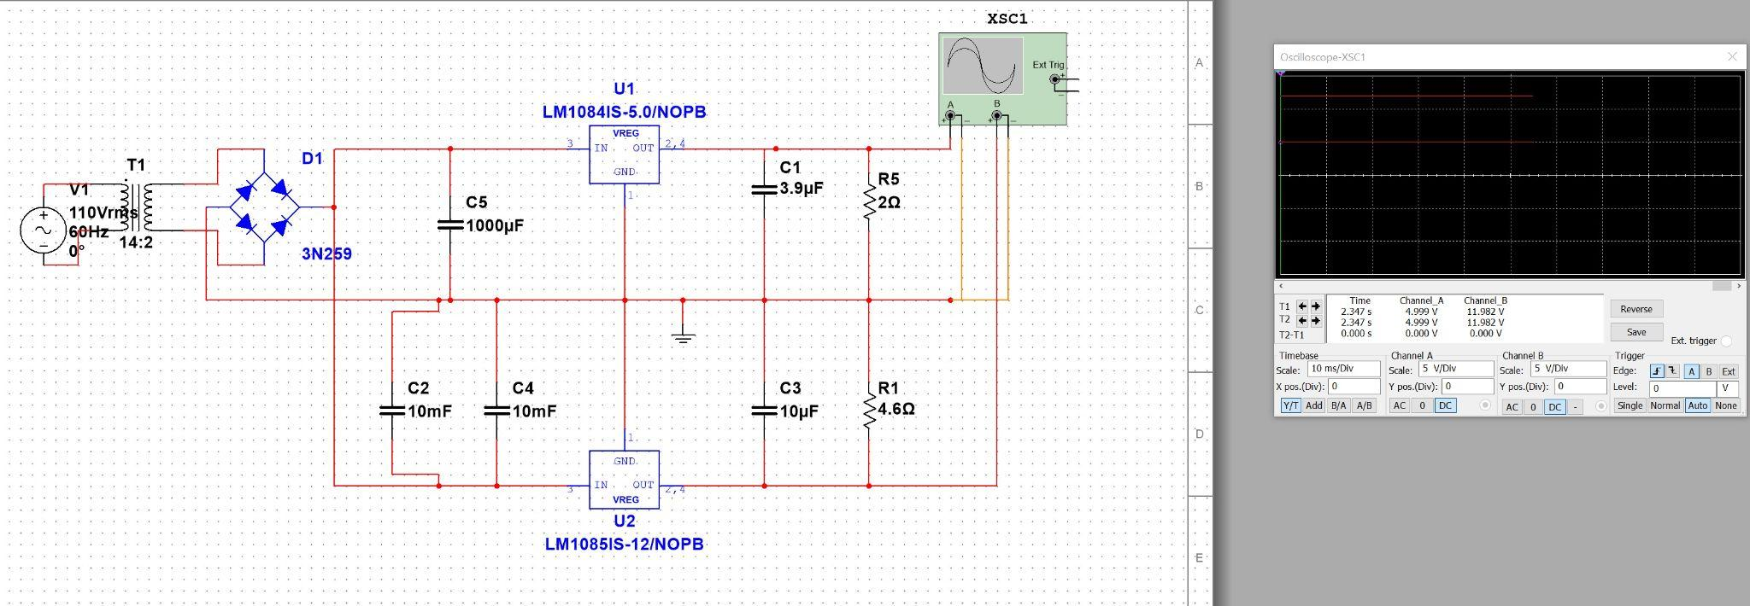

*Figure 1 - Multisim design for entire system*

* + - 1. Next I moved the system to a Perfboard for physical testing. This setup can be seen in the image below

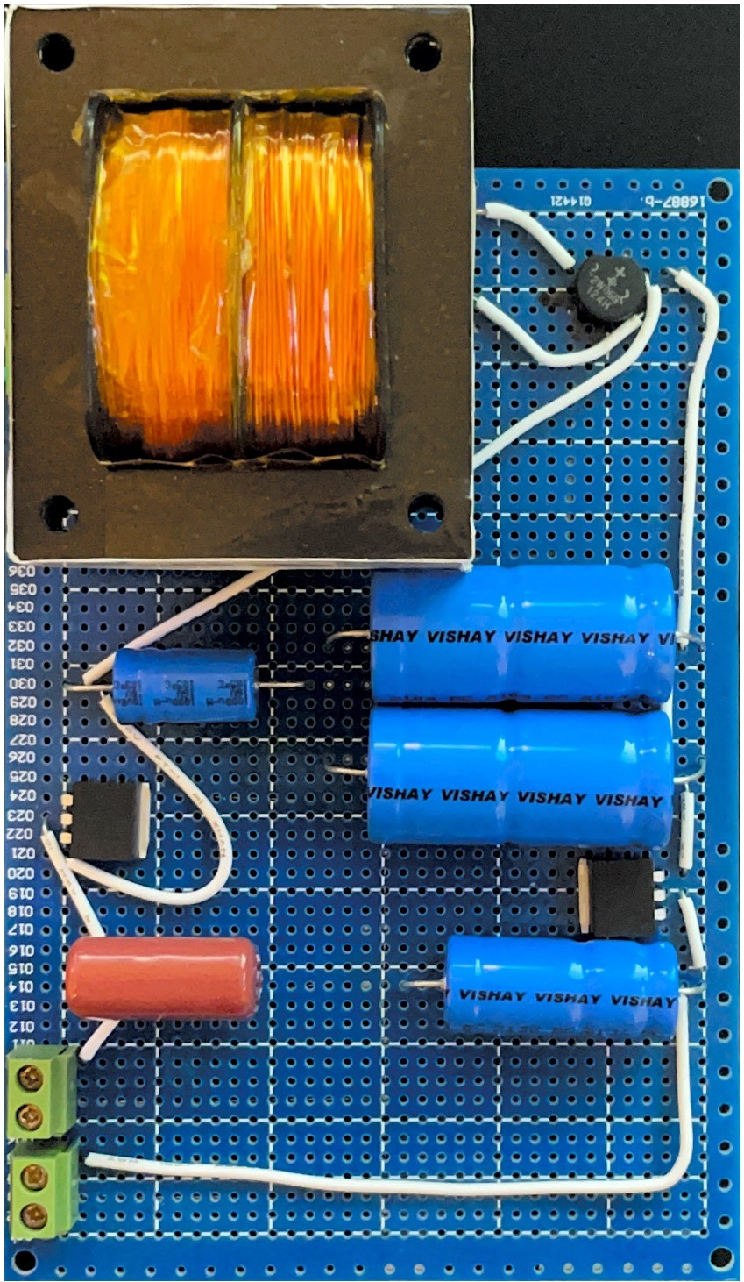

*Figure 2 - Perfboard design*

* + - 1. Finally I created a schematic in Altium and have begun designs of the PCB but Abhi and I will be designing that over the summer in order to have everything from the power supply and MCU on one PCB

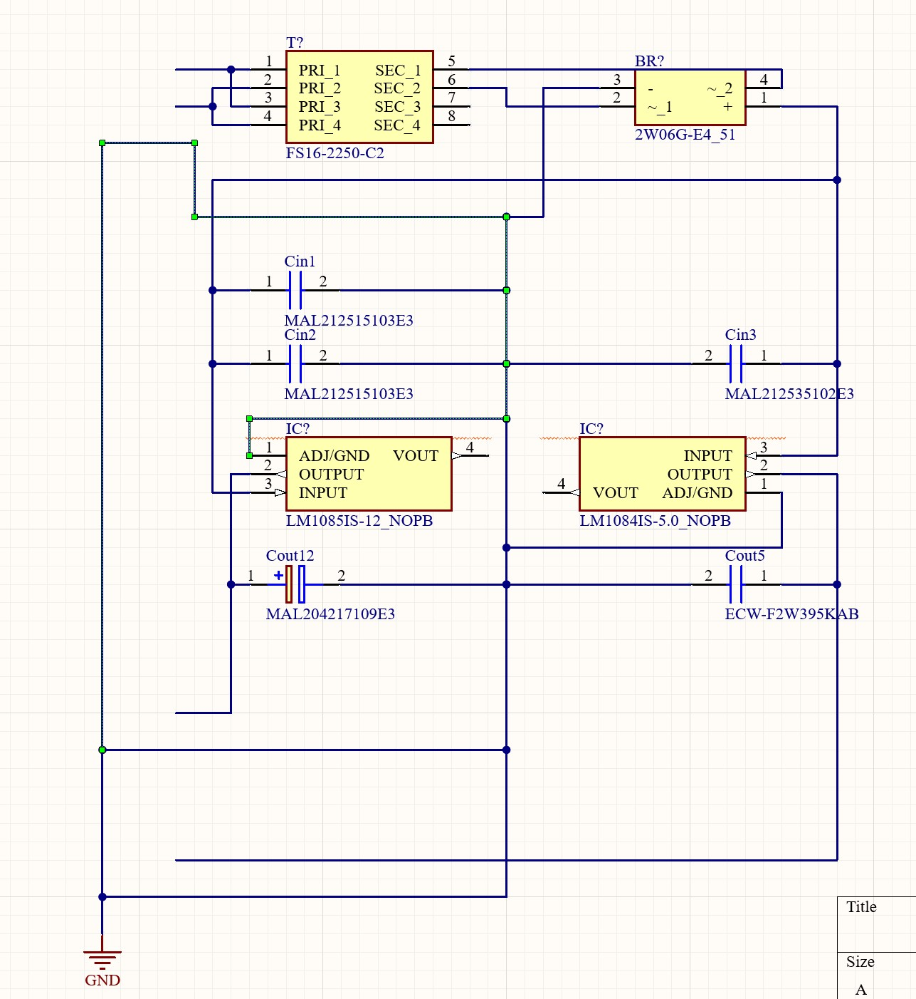

*Figure 3 - Altium schematic*

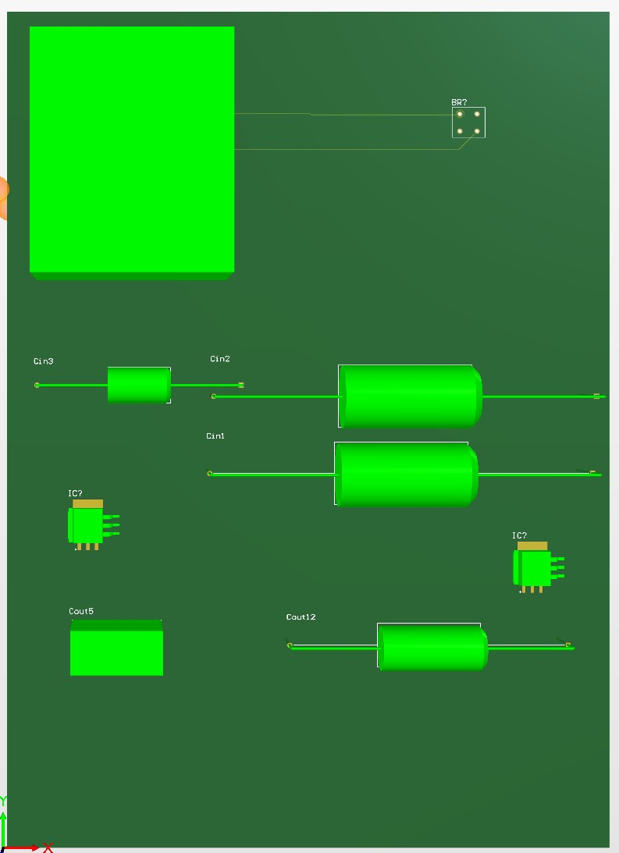

*Figure 4 - Altium PCB 3D view of preemptive design*

## ***Power Supply Validation***

* + 1. Before I moved the system to the perf board I made sure that the multisim schematic gave the correct outputs for different loads

| Schematic |  |  |  |
| --- | --- | --- | --- |
| 5V Buck | Current(A) | Load(W) | Output(V) |
|  | 0.1 | 0.5 | 5.004 |
|  | 0.5 | 2.5 | 5.003 |
|  | 1 | 5 | 5.002 |
|  | 1.5 | 7.5 | 5.001 |
|  | 2 | 10 | 5 |
|  | 2.5 | 12.5 | 4.999 |
| 12V Buck | Current(A) | Load(W) | Output(V) |
|  | 0.1 | 1.2 | 12.003 |
|  | 0.5 | 6 | 12 |
|  | 1 | 12 | 11.995 |
|  | 1.5 | 18 | 11.991 |
|  | 2 | 24 | 11.987 |
|  | 2.5 | 32 | 11.983 |
|  | 3 | 36 | 11.979 |

*Table 1 - Tested values for different loads on each output in the multisim simulation*

* + 1. For the testing on the perfboard I first used a oscilloscope to measure the output voltage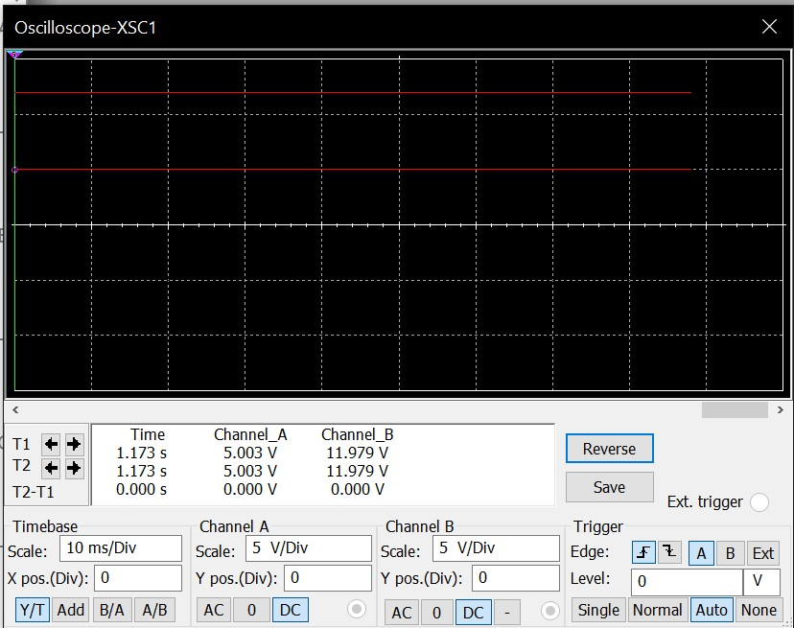

*Figure 5 - oscilloscope output of perfboard*

* + 1. E-load test on perfboard

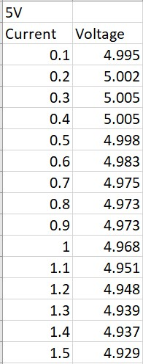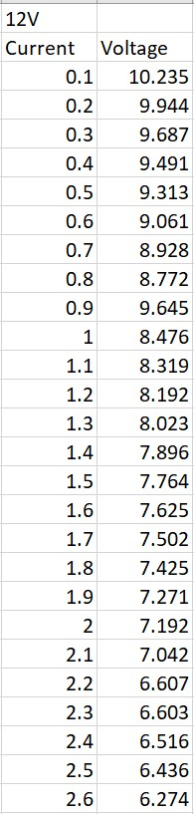

*Table 2 - E-load Values for the 5V and 12V buck converters*

## ***Power Supply Conclusion***

Throughout the semester I have been designing and redesigning my circuit. Each time I would get suggestions from the TA or Professors or the power load from the MCU would be changed and I would have to redesign the circuit. This led to a severe time crunch in the end and I had to settle for a simpler circuit. This led me to the circuit that was demoed. During the testing of the load on the circuit, the components overheated leading to one melting. Due to this failure I re-configured the transformer layout to have half the power output. This led to the system no longer overheating but the 12V output no longer sustained the correct voltage or power output. I continued the validation and testing with this configuration to maintain the integrated demo with my lab mates. I will be attempting to alter my designs based on the feedback I received from Dr.Lusher over the summer. This will hopefully result in a completed power supply and near complete PCB design before we begin the 404 semester.

# **Microcontroller Subsystem**

## ***Subsystem Introduction***

The Microcontroller Subsystem entails the control of the dispensing system as well as stock checking and WiFi connection. This system is controlled by an esp32 that is connected to a wireless network and an MQTT broker. This MQTT broker is the primary method of controlling the dispenser. The dispenser consists of a Skittle solenoid actuator and a persistaltic pump liquid dispenser

## ***Subsystem Details***

Testing of the Subsystem was conducted in stages, this was to ensure that firstly the WiFi connection could be accurately established to my personal hotspot, this information was hardcoded. After connecting to WiFi, MQTT connection was next on the list of items to be established, MQTT is takes specific keys to test, and this requires message topics to be subscribed to and read in using a callback function for the message. This message can then be used to set internal variables for loops to dispense skittles and juice.

**ESP32 microcontroller + Control Relays + Connection Indicator**

* This perf board constraints the esp32 that we are using, as well as 2 relays for controlling both dispenser, and 5V, 12V inputs from Holden’s Power Supply, as well as the outputs to the dispensers, which both operate at 12V. This dispensing mechanism was more of a proof of concept knowing that the final product should rely on MOSFETs to control both 12V dispensers as the relays are overkill. There is also a Green LED that signals on when MQTT connection has been established, this is to know that the system is connected to the broker for debugging purposes, this will be sent over to the nextion screen next semester which will alert the user of the connection status.

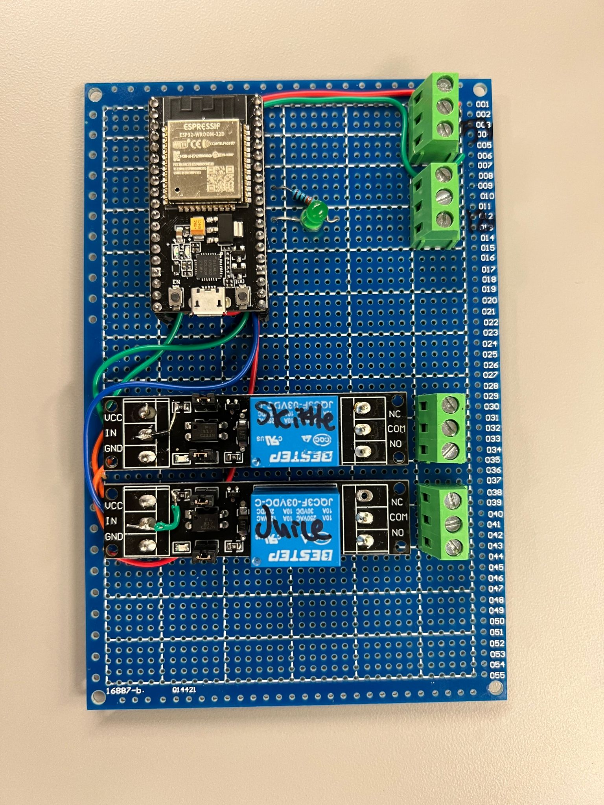

Figure 6 - MICROCONTROLLER CONTROL BOARD

**Solenoid Dispenser**

* Modeled a gravity fed skittle dispenser that is responsible for tracking the dispensing of the skittles down to an individual skittle, which gives fine grain control of the sugar that is dispensed to the user. This model was designed in solidworks and then iteratively printed, with first the mechanism being built, and then the funnel and base holder.

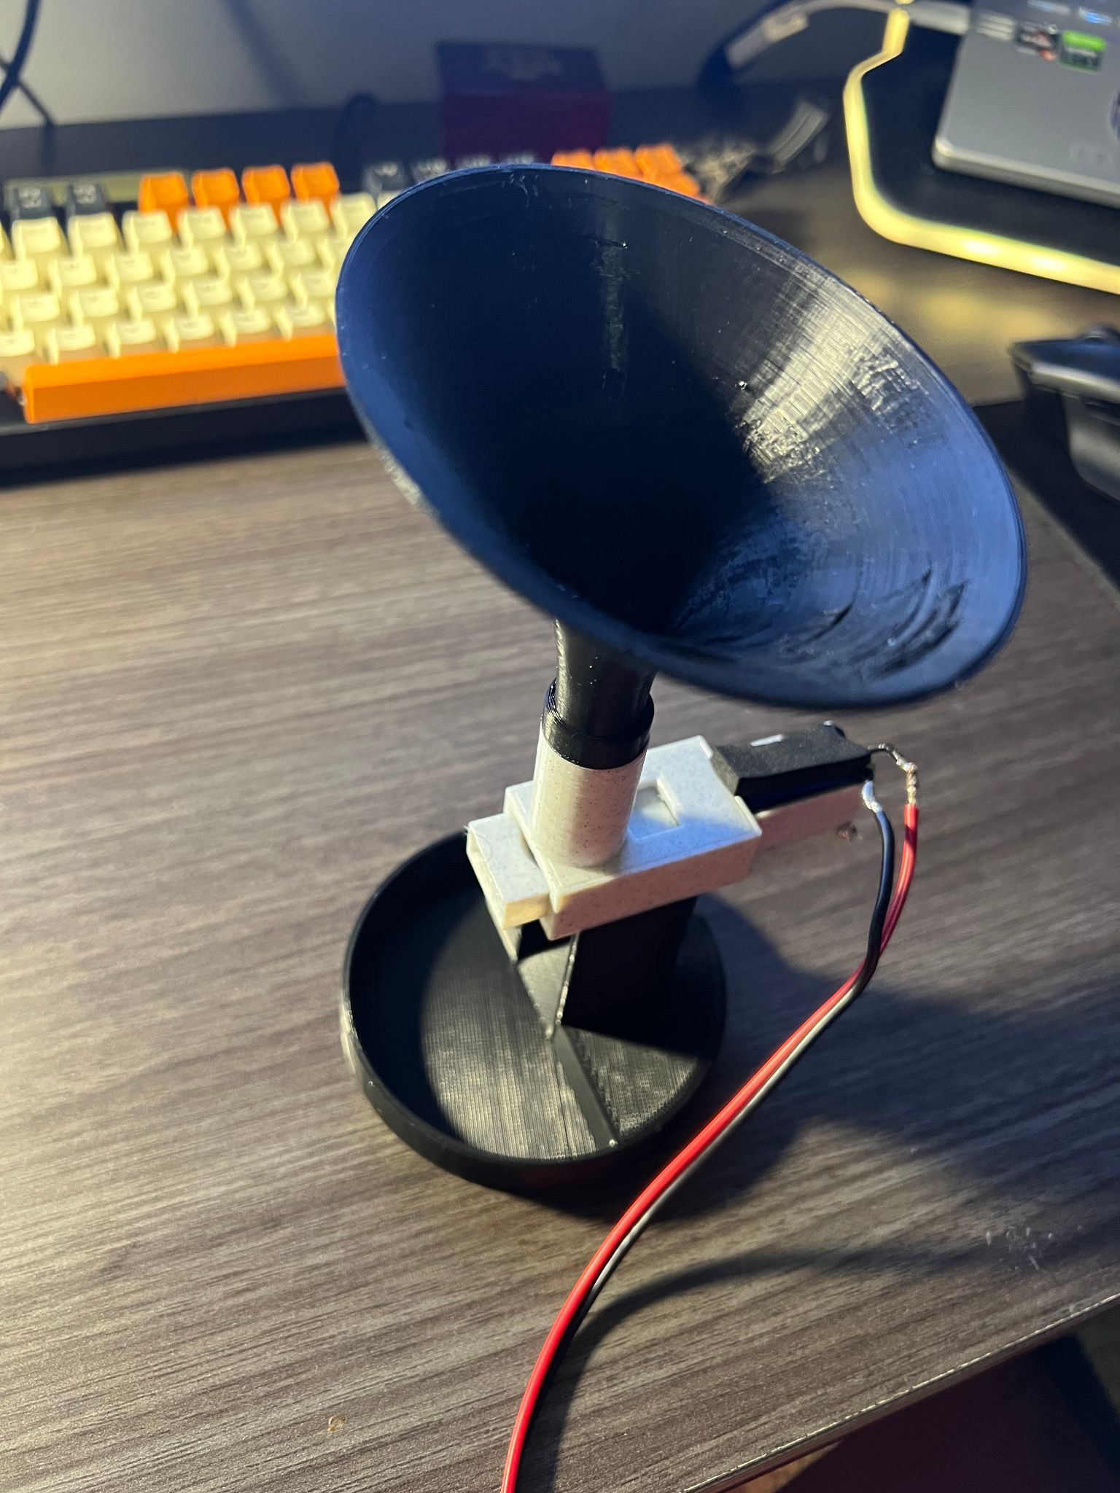

FIGURE 7: SKITTLE DISPENSER

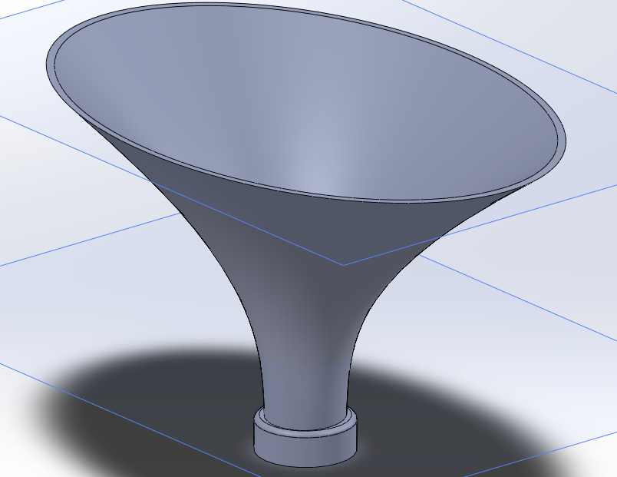

FIGURE 8: SKITTLE DISPENSER FUNNEL

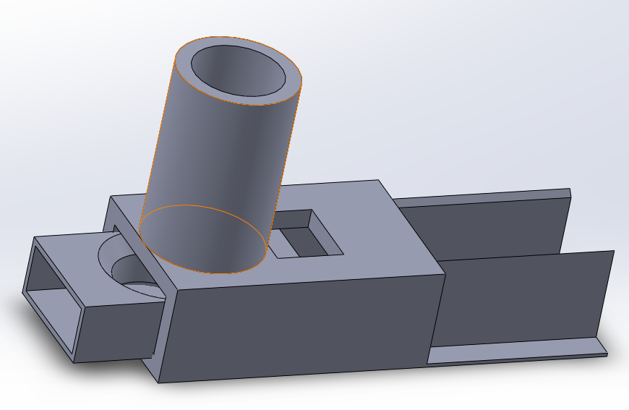

FIGURE 9: SKITTLE DISPENSER ACTUATOR

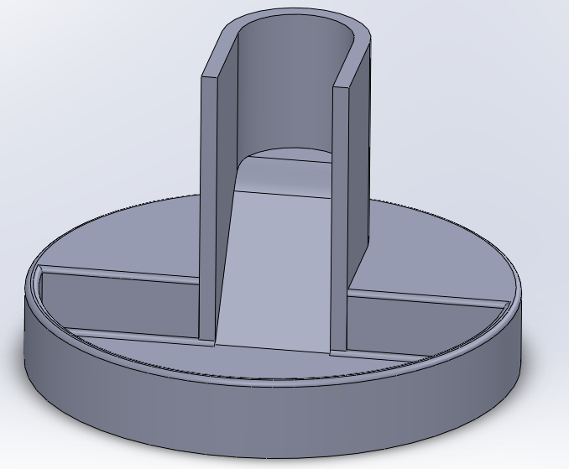

FIGURE 10: SKITTLE DISPENSER TRAY

**Peristaltic Pump**

* The Juice dispenser works off a Peristaltic pump that draws 12W, this came as is and works relatively well to dispense an accurate amount of liquid over time, further improvements in the dispensing accuracy will be done next semester using a flow-meter.

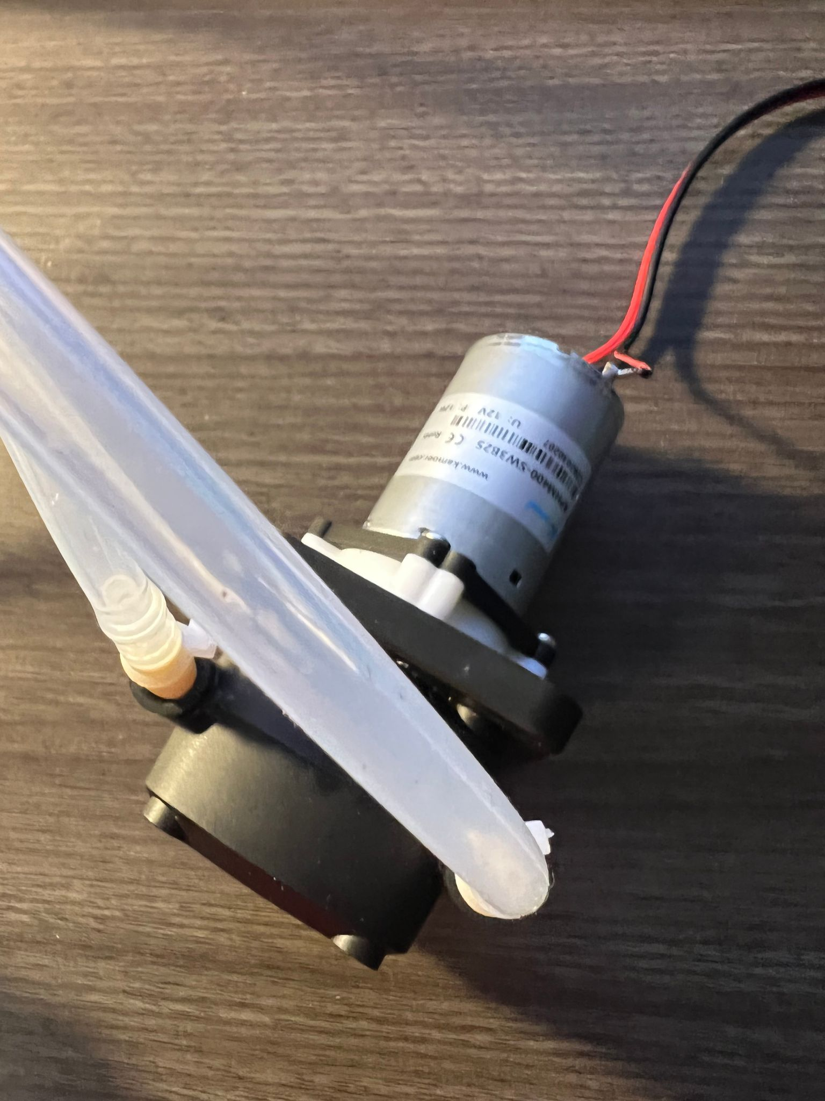

FIGURE 11: LIQUID DISPENSER

## ***Subsystem Validation***

MQTT connection test

* Ensure that MQTT does not lose connection during a 24 hour period
* Successful run, with no disconnects or reconnect attempts, print out any reconnection attempts to the serial console

Juice Dispensing Test

* Confirmed dispensing consistency with 5 trial runs with same 15g request, ±5% volume between runs

MQTT message test with dispenser

* Sent 10 (1g) dispense messages in rapid succession (2-3 seconds), received confirmation of all 10 dispense messages, as well as 10 skittles dispensed

# ***Subsystem Conclusion***

The subsystem is a great starting point for what our team needs in order to complete our finished product in ECEN 404. Although we have to make new and improved designs for the dispenser as well adding features, which comes with additional hardware such as a screen and sensors, these additions will build off what we have made in ECEN 403. The dispenser completed its task of dispensing skittles and juice in an accurate and reliable manner. The connectivity of the System was not spotty during our tests as well as during the demo.

Looking forward to next semester, this dispenser system will be revamped with a newly designed feeding system for the skittles so the skittles cannot get jammed, and will hold more skittles. Another feature to be added is a flowmeter on the output of the liquid dispenser, which will ensure accurate dispensing as well as checking to make sure the dispenser actually dispensed the liquid. Finally a Touch display will be integrated into the user interface so that the user can dispense in offline mode or when they dont have access to their phone. The system will be designed around its housing as well, so that the dispenser can be fed easily and have a pleasing appearance in the household.

# **Mobile Application Subsystem Report**

## ***Mobile Application Introduction***

The mobile application grants the user of the C6H12O6-MATE Hypoglycemic System the ability to access many functions of the system remotely, as well as several features outside of the physical device. The application will allow the user to dispense remotely, access previous dispense information, receive stock notifications, and interface with glucometers. The specifics for the mobile application are outlined below, as well as validation information and general implementation.

* 1. ***Mobile Application Details***
     1. ***Implementation***

The application was implemented through the use of several technologies, each of which will be outlined below.

* + - 1. ***React Native & Expo***

React Native is a UI Framework developed by Facebook that allows for the creation of native applications using Javascript and JSX languages. Expo is a framework on top of React Native that adds several modules and packages to create applications with ease. By combining these two UI Frameworks, application development can be accomplished much quicker than through the use of native code libraries and written for cross-device compatibility. React Native and Expo serve as the foundation for the mobile application.



Figure 12 - React Native Logo Figure 13 - Expo Logo

* + - 1. ***Google Firebase & Firestore***

Google Firebase is a platform with many helpful systems for the creation of both web and mobile applications. For the purpose of this mobile application, Firebase offers the authentication system as well as their Firestore database system. Firebase and Firestore were chosen for a few reasons for the purpose of this application. Authentication is easy to implement into the application thanks to the React Native APIS available by Google. Firestore is a NoSQL database that allows for easy data manipulation and creation, as well as rapid scaling. Our Firestore implementation is organized into one collection referred to as “dispenses”, with each entry being named to a unique ID. Each entry (or page, as Firestore calls them) contains a candy field for storing the candy dispense amount, liquid field for the liquid dispense amount, date field for the date of the dispense, as well as a UID field to organize and display within the application by user.

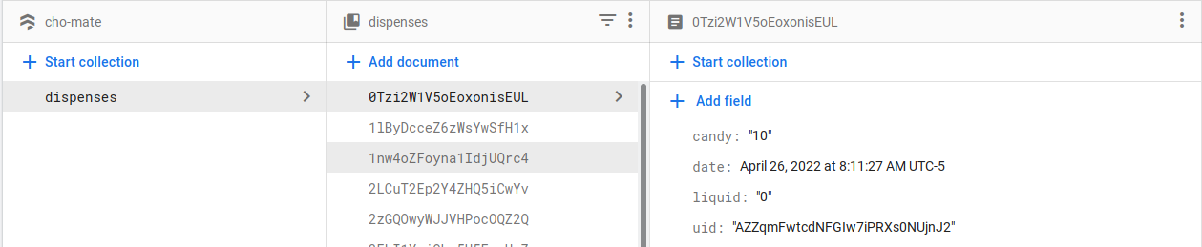

Figure 14 - Firestore organization



Figure 15 - Firebase Logo

* + - 1. ***MQTT & CloudMQTT***

MQTT is a communication protocol to allow IoT devices to communicate quickly and efficiently over the TCP/IP protocol. Devices subscribe to topics that other devices publish to, and vice versa to allow cross-communication. The machine and device have several channels for communication that are outlined below.

| **Channel** | **Purpose** |
| --- | --- |
| app/amount/liquid | Application requests amount of liquid available in machine |
| app/amount/candy | Application requests amount of candy available in machine |
| app/response | Response from machine, such as SUCCESS or FAILED on dispensing jobs |
| chomate/liquid | Application tells machine amount of liquid to dispense |
| chomate/candy | Application tells machine amount of candy to dispense |
| chomate/request | Used to determine what kind of request from machine, such as STOCK or DISPENSE |

Table 3 - MQTT Channels



Figure 16 - MQTT Logo

* + 1. ***Design***

The various application screens are shown below.

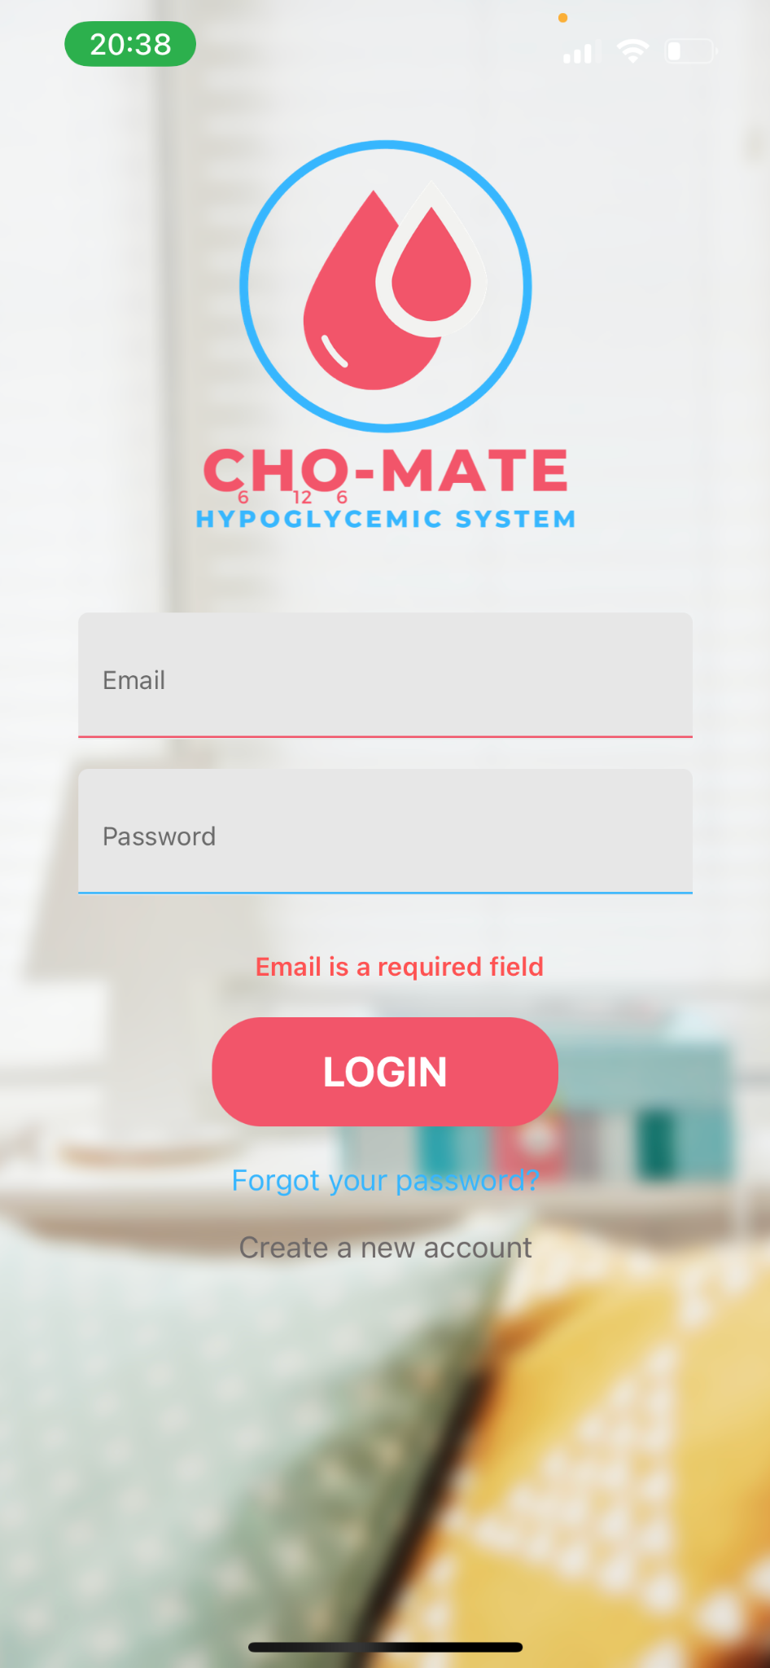

Figure 17 - Login Screen

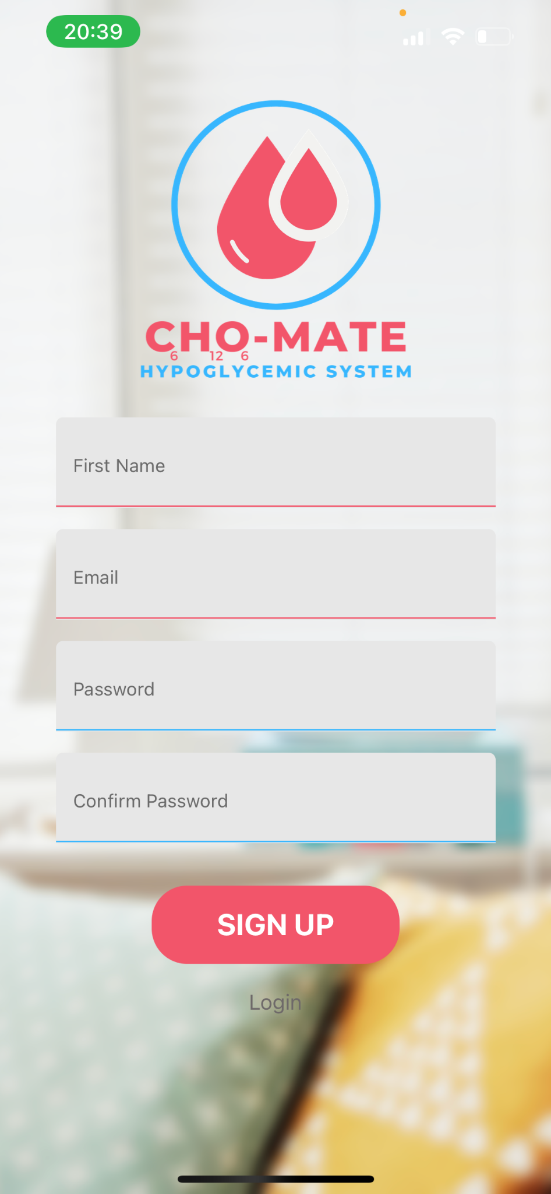

Figure 18 - Sign Up Screen

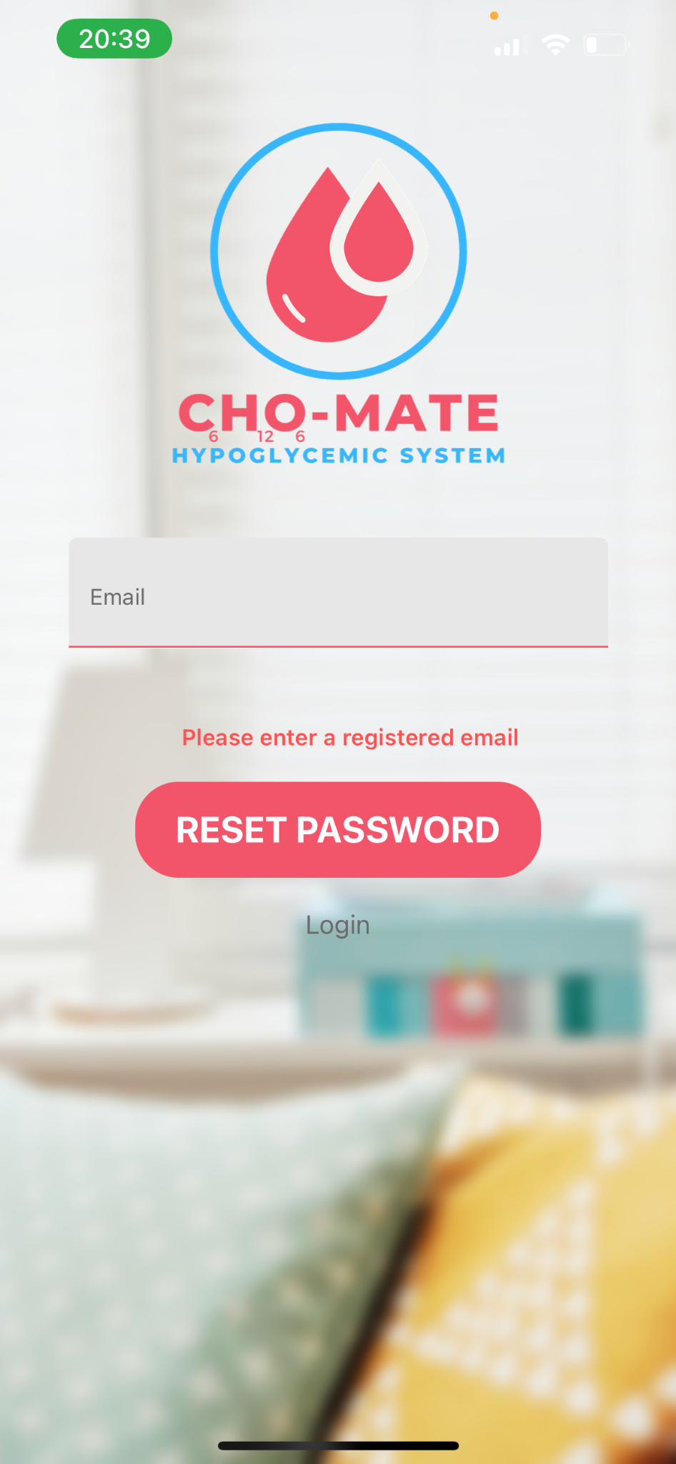

Figure 19 - Forgot password

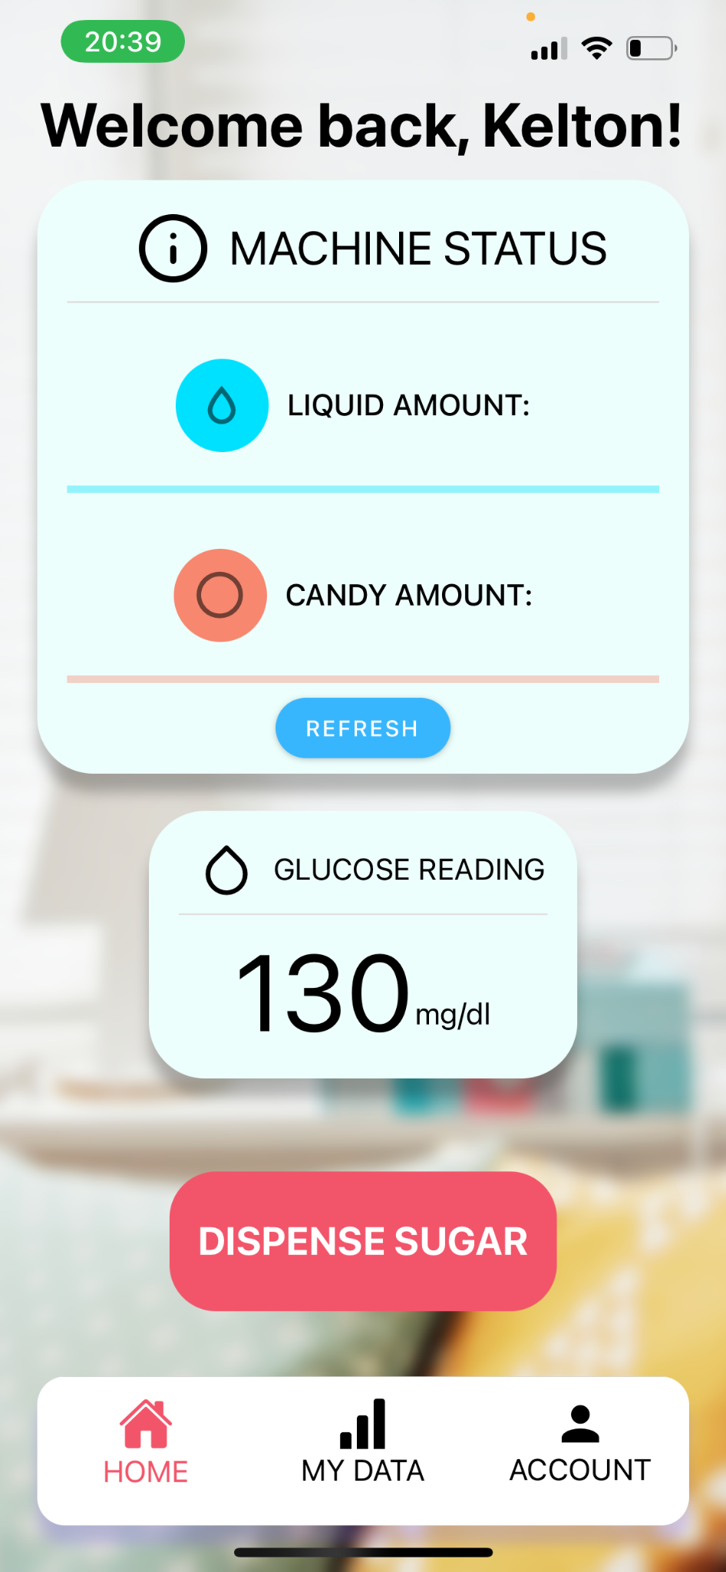

Figure 20 - Home Screen

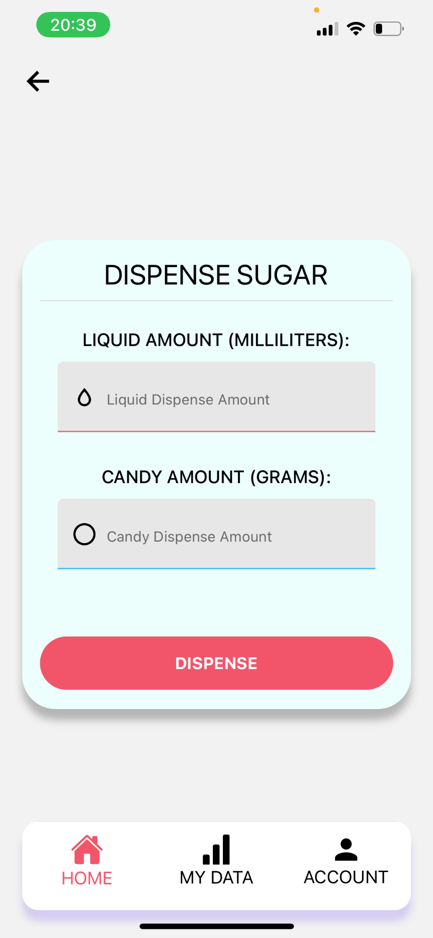

Figure 21 - Dispense Screen

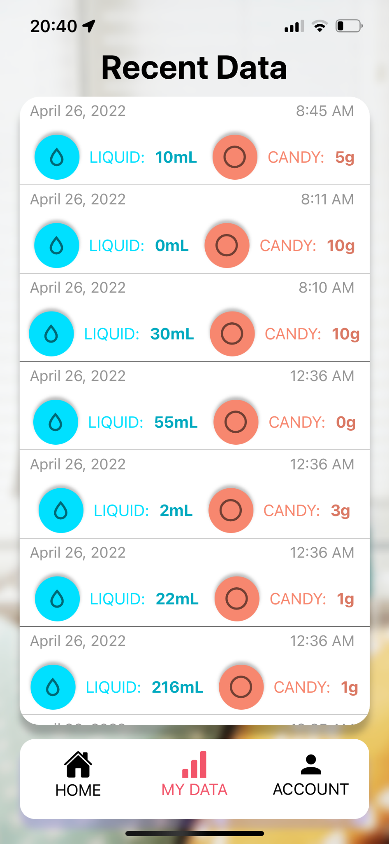

Figure 22 - Recent Data Screen

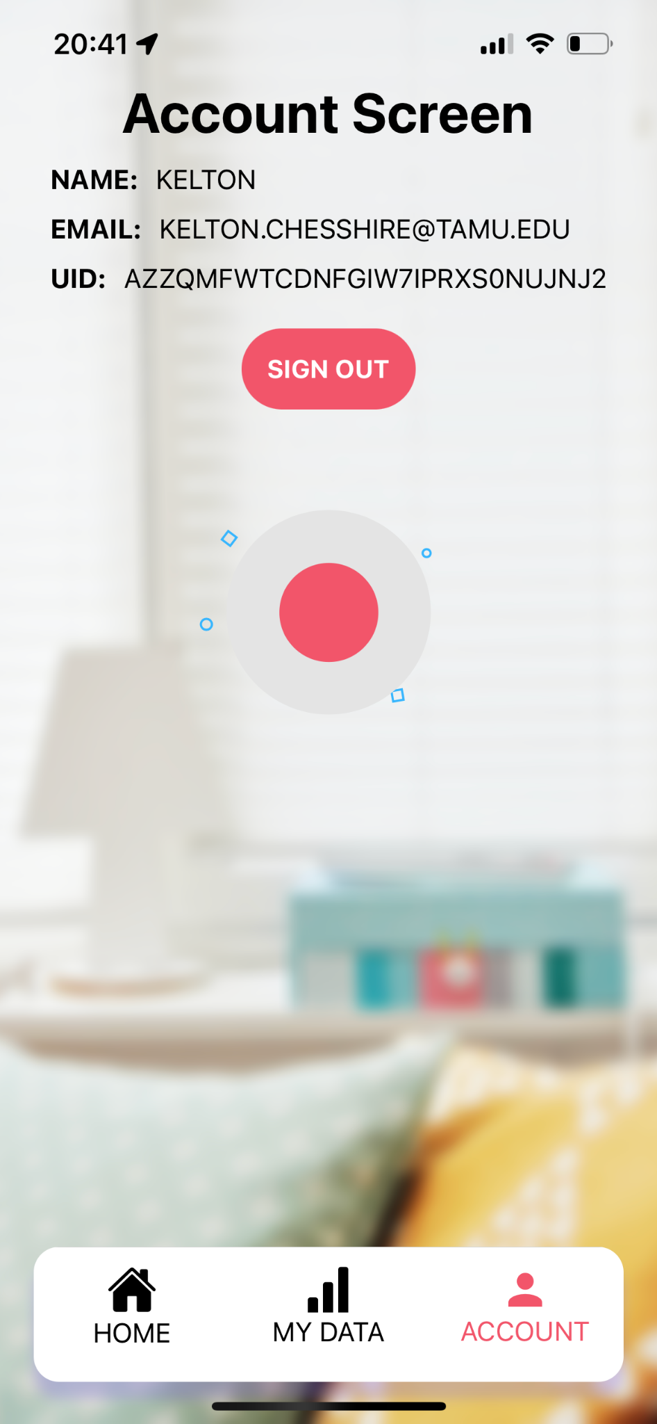

Figure 23 - Account Screen

## ***Mobile Application Validation***

Validation for the mobile app occurred throughout development. Expo allows for a development server to be run and loaded on your device, with any changes made to code that is saved to be reflected on the device. As such, code changes such as navigation systems or various elements on each screen validation occurred during the process. Database and MQTT validation occurred similarly, as database connection was tested alongside the development of the screens. Database connection, disconnection, object creation and retrieval were all tested. MQTT testing followed suit.

## ***Mobile Application Conclusion***

The application operated as expected in all stages. Working with Firebase and the MQTT framework led to some interesting challenges that needed to be overcome, but altogether the application performs as expected. Database connection is speedy, and MQTT communication also occurs very quickly. The application should provide an adequate method for the user to interact with the device as intended.